Namibia

## Respect for rule of law (ROL) data

The data set shows the data on the respect of the rule of law for the country.

## # A tibble: 19 x 5  
## country iso3c date ruleOfLaw ruleOfLawCategory4   
## <chr> <chr> <dbl> <dbl> <chr>   
## 1 Namibia NAM 1996 0.251 ROL moderately respected   
## 2 Namibia NAM 1998 0.312 ROL moderately respected   
## 3 Namibia NAM 2000 0.221 ROL moderately respected   
## 4 Namibia NAM 2002 0.327 ROL moderately respected   
## 5 Namibia NAM 2003 0.316 ROL moderately respected   
## 6 Namibia NAM 2004 -0.00282 ROL moderately disrespected  
## 7 Namibia NAM 2005 -0.0664 ROL moderately disrespected  
## 8 Namibia NAM 2006 0.121 ROL moderately respected   
## 9 Namibia NAM 2007 0.102 ROL moderately respected   
## 10 Namibia NAM 2008 0.348 ROL moderately respected   
## 11 Namibia NAM 2009 0.188 ROL moderately respected   
## 12 Namibia NAM 2010 0.155 ROL moderately respected   
## 13 Namibia NAM 2011 0.132 ROL moderately respected   
## 14 Namibia NAM 2012 0.253 ROL moderately respected   
## 15 Namibia NAM 2013 0.267 ROL moderately respected   
## 16 Namibia NAM 2014 0.148 ROL moderately respected   
## 17 Namibia NAM 2015 0.190 ROL moderately respected   
## 18 Namibia NAM 2016 0.362 ROL moderately respected   
## 19 Namibia NAM 2017 0.239 ROL moderately respected

## Respect for rule of law (ROL) trend

The plot shows the trend of the respect for the rule of law for the country.

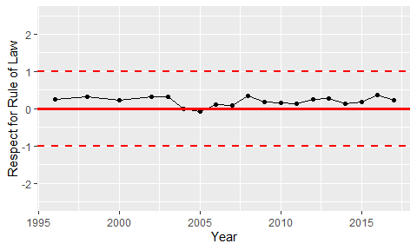

Trend of the Respect for the Rule of Law